

Scio PreK Supply List 2024-25

- 1 regular-sized backpack

- A change of clothes, including underwear and socks (will be kept in student cubby or backpack)
- Toothbrush and toothpaste (will be kept in child’s cubby)

- Optional: small blanket or pillow for rest time
We would greatly appreciate if you could help with the following items:

- 2-4 boxes of tissues

- 2-4 packs of baby wipes (not anti-bacterial)

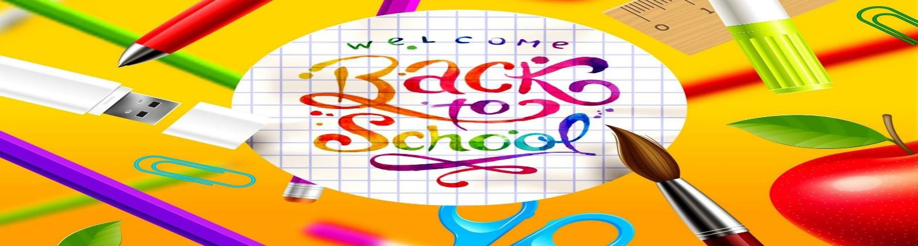
Kindergarten School Supply List

*1 backpack (large enough to put folders in it)
*1 supply box
1 package of 24 count crayons 1 package washable markers
1 (4 count) package dry erase markers 10 glue sticks
*1 set of headphones (headphones are for computer use only at school. They must be over the ear style. No ear buds. See picture for example)
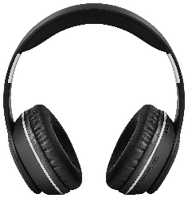

We would greatly appreciate if you could help with the following items: 2-4 containers disinfectant wipes
1-2 boxes of tissues
1-2 packages gallon sized Ziplock bags
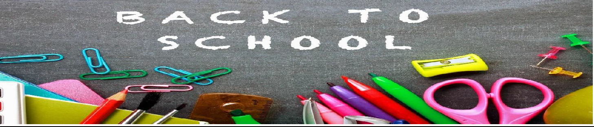

Scio Central School
First Grade Supply List 2024-2025
- Backpack
- Headphones (no earbuds)
- 1 (1inch) white 3 ring binder (with clear front and back sleeve)
- Plastic pencil/supply box
- 25 sharpened pencils
- 1 hand-held eraser (please no pencil top erasers)
- Scissors
- 6 glue sticks
- Crayons (box of 24)
- 4 thin (black) dry erase markers
- 1 empty shoebox

We would greatly appreciate if you could help with the following items:
- 3-4 boxes of tissues

2nd grade supply list for Scio Central School 2024-2025

- 1 hard pencil case
- 1 pack dry erase markers
- 1 pocket folder with prongs
- 1 pair of headphones (no earbuds) – optional
- 1 box of crayons
- 1 pack of colored pencils
- 1 pack highlighters
- 1 block eraser
- 1 package blank index cards

We would greatly appreciate if you could help with the following items:
- 1-2 container disinfectant wipes
- 1-2 boxes of tissues

See you soon!
Mrs. Burdick & Ms. Washburn

Third Grade Supply List
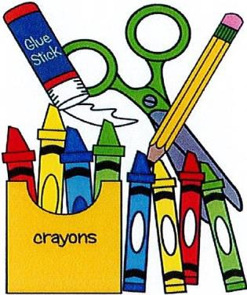

Mrs. Root and Ms. Harvey

- Ten Glue Sticks
- One marble, bound, composition notebook
- 40 #2 pencils (non-mechanical) NO PENS
- One box of colored pencils
- One pencil storage box
- One package of eraser caps
- One: 1 inch three ring binder with pockets
- Four expo dry erase markers

We would greatly appreciate if you could help with the following items:

1-2 boxes of tissues

Thank you for coming to school prepared!
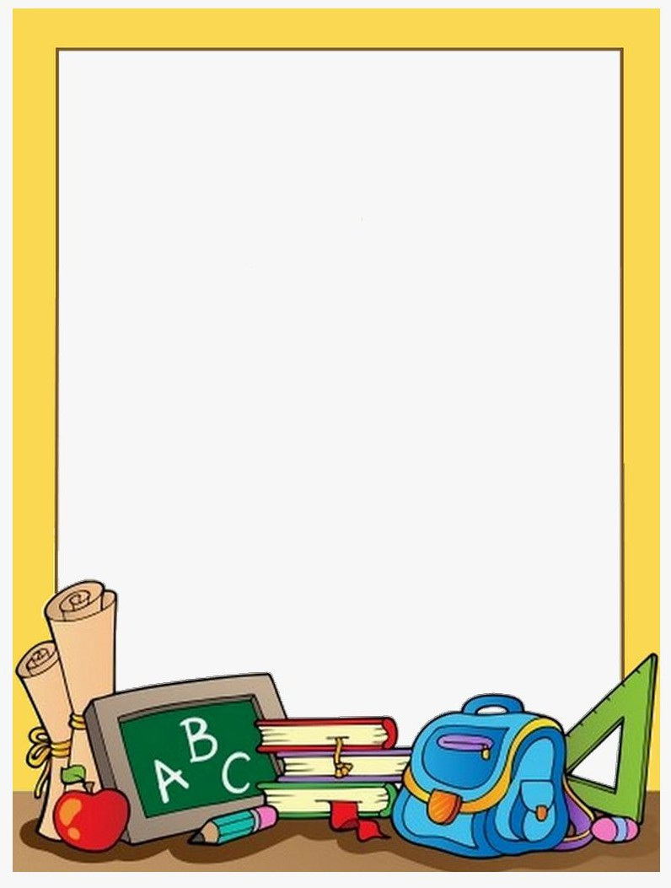

2024-2025 Scio Central School 4th grade Supply List

**No pens, mechanical pencils or Trapper Keepers are needed for 4th
grade, Thank you.

- 24 Pencils
- 2 Highlighters
- 2 – two pocket folders
- One (1) 4 – pack dry erase markers
- 2 Composition Books
- 1 box of colored pencils
- One (1) pair of earbuds or headphones
- Erasers (not pencil top style)

We would greatly appreciate if you could help with these items:

- 2-4 boxes of tissues

We look forward to seeing you in the new school year! Dr. McKinley & Mr. Wagner


Fifth and Sixth Grade Supply list
2024-2025
***Please label ALL items with a permanent marker.***

It would very helpful and appreciated if you could bring the following items on the first day of school:
- Pencil eraser caps
- Several #2 pencils.
NO MECHANICAL PENCILS, PLEASE! NO PENS, PLEASE!
- TWO marble bound composition notebooks (NOT SPIRAL)
- One black ULTRA FINE point permanent marker (Sharpie)
- Two different colored highlighters
- TWO laminated (shiny) or plastic folder with pockets
- Earbuds or headphones (optional)
- Colored pencils, 12 pack
- Pencil case for locker

We would greatly appreciate if you could help with the following items: 2-4 boxes of tissues

Thank you for coming to school prepared!

